
Integrated Municipal Information System (IMIS)
Innovative Solution Pvt. Ltd (ISPL)
Emptying Information Collection Mobile App
User Manual
Empowering Development through Data-driven Innovation and Information Technology Solutions

Emptying Information Collection Mobile App User Manual
Base IMIS 2022-2026 by ISPL & GWSC-AIT is licensed under CC BY-NC-SA 4.0 | Customized for DNCC
Version 1.0.2

Table of Contents
Chapter 1 Introduction 1
1.1 Purpose 1
1.2 Target Audience 1
Chapter 2 App Installation 2
2.1 Installation Procedure 2
Chapter 3 Accessing the IMIS 4
3.1 Opening the app/ Login 4
Chapter 4 Dashboard 6
4.1 Navigate to Dashboard 6
Chapter 5 Collecting Emptying Services Information 7
5.1 Navigate to Emptying Service 7
5.2 Tools 8
5.3 Emptying Service Data Collection 10
Chapter 6 MISCELLANEOUS (PERMISSIONS) 25

- Introduction
  - Purpose
This document is designed to guide Desludging Vehicle Operators on how to use the Supervisory Assessment and Emptying Details Collection Mobile App. First, the Emptying Operators do the Supervisory Assessment of an application before carrying out the emptying process for the application. The app collects emptying information while providing the emptying service, enabling real-time updates. The mobile application is used by emptying operators to collect information such as emptying start and end time, number of trips, total cost for emptying, and the payment receipt number. Emptying details can be viewed in real-time by the help desk and other municipal staff who have access to this module. The user manual details the step-by-step procedure of all implemented facilities within the App. It is to be noted that information related to the actual emptying operation can also be entered into the system through the Web interface. The main purpose of this application is to provide the user with guidance to fill in the details of the emptying service and view the applications received. It provides an easy-to-use interface that connects the emptying operator with the IMIS web application.
  - Target Audience
Targeted users of this manual are Desludging Vehicle Operators of the Municipality or Outsourced Agency. This manual guides the performance of details related to actual emptying operations.

- App Installation
An APK file will be made available in a common access location or shared via a link that can be downloaded and installed on your device.
- Installation Procedure
- Download the APK file on your device and go to the ‘Downloads’ folder in the ‘File Manager’.
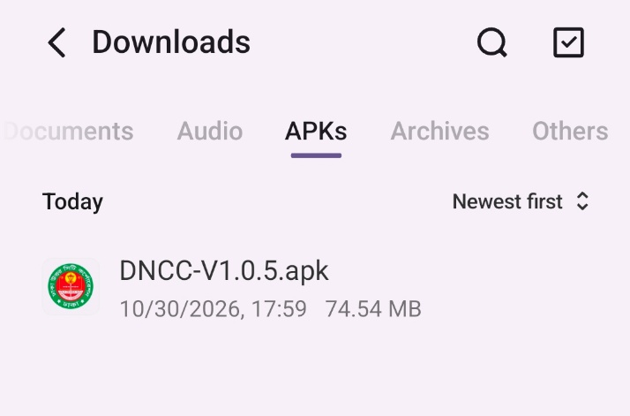
                - . APK file
- Locate the corresponding .apk file and tap on it. The installation process will begin.
- Tap on ‘SETTINGS’ and allow access if the system asks for permission to install the app from an unknown source.
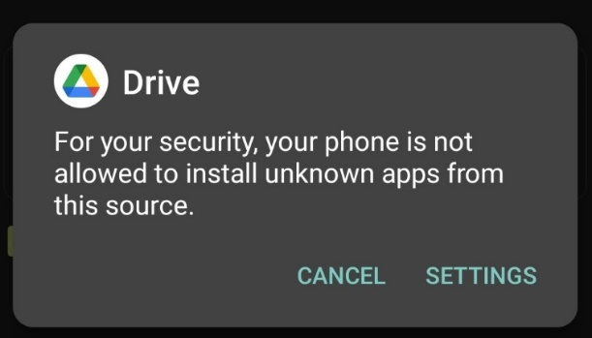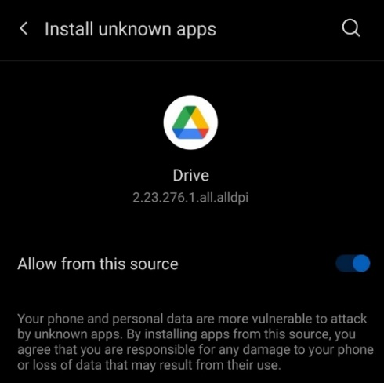
                - Access Permission
- Tap on ‘INSTALL’. An ‘Installing…’ progress bar will be displayed.
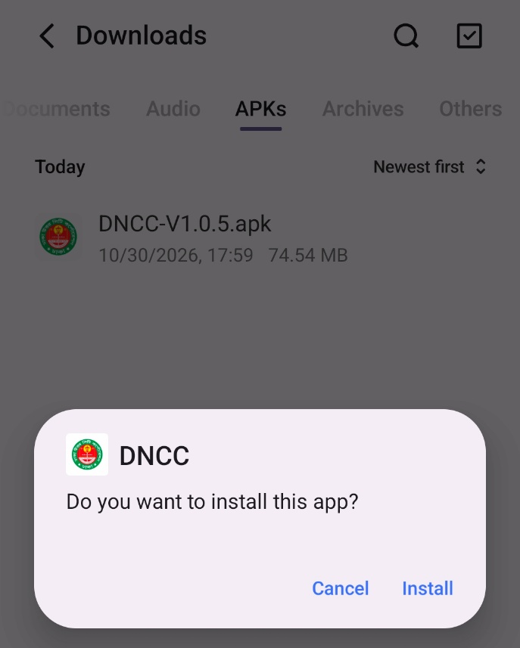
                - Installation process
- Tap on ‘Open’ after the installation process is completed.
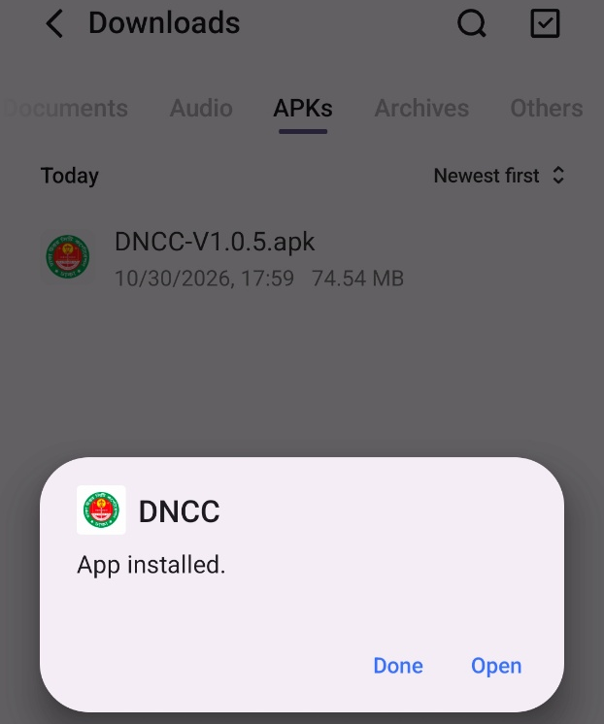
                - opening app
Overview:
- The installed app can also be accessed from the App drawer or Launcher.

- Accessing the IMIS
- Opening the app/ Login
- Open the IMIS mobile application. The Login screen will be displayed.
- Enter the email address and password provided by the Municipality Administrator.
- To keep the user signed in, select the Remember me checkbox, if required.
- Tap 'Log In' to access the application.
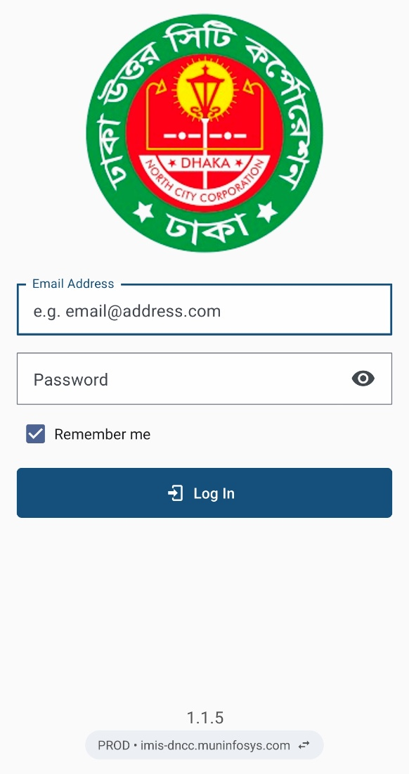
                - Login
Switching Between Servers
- The application allows users to switch between the Production (PROD) and Staging (STAGING) servers.
- The currently selected server and its URL are displayed at the bottom of the Login screen, below the application version number.
- Tap the displayed server URL to open the 'Switch server' confirmation dialog.
- Tap 'SWITCH' to change to the other server, or tap 'CANCEL' to remain on the current server.
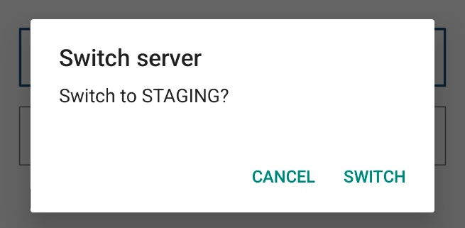
                - Switch Server Confirmation
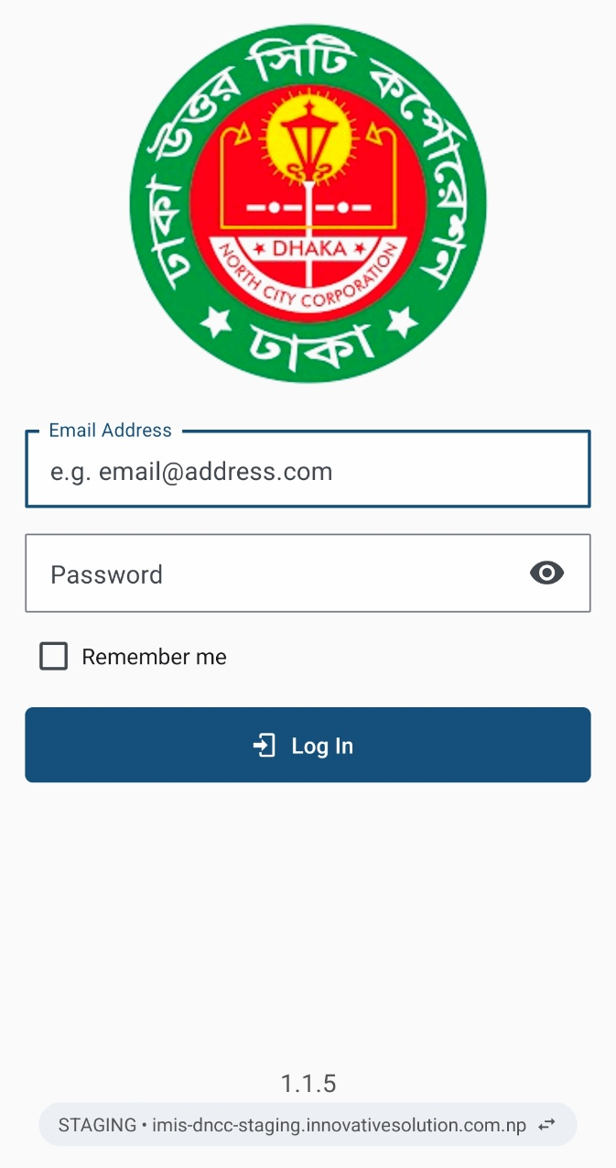
- After switching, the selected server name and URL will be updated at the bottom of the Login screen.
- Verify that the correct server is selected before entering the login credentials.

Overview:
- This login credential is created and provided by the Municipality IT Admin to the user role Emptying Operator.
- The application retains the login information until the user's session becomes inactive and expires.
- It is to be noted that GPS needs to be turned on while using the mobile application. When the user is using the app for the first time. The user must provide the location permission to the app.
- Once a successful login, the user is redirected to the Dashboard screen.

- Dashboard
  - Navigate to Dashboard
- After successful login, a dashboard page is displayed.
- The user must select the ‘Emptying Service’ card to enter details related to the emptying service.
- To switch language, tap the language icon beside the three dots, which will pop up and display the language code. Select the language.
- Tap the three dots at the top right corner to get the log-out option.
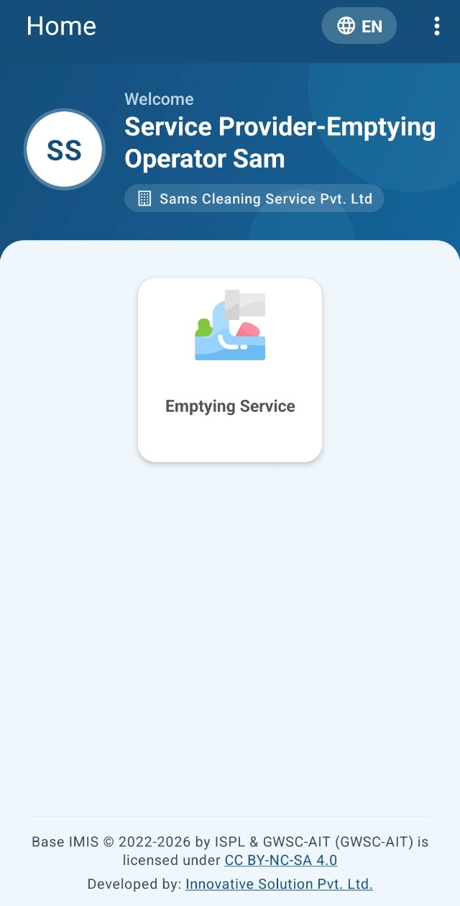
                - Dashboard
Overview
- Once the user is successfully logged in, the user is redirected to the Dashboard screen.

- Collecting Emptying Services Information
- Navigate to Emptying Service
- For collecting the emptying service details of the application, tap on ‘Emptying Service’ on the dashboard.
- Once tapped, the user will be directed to a list of applications that have been created.

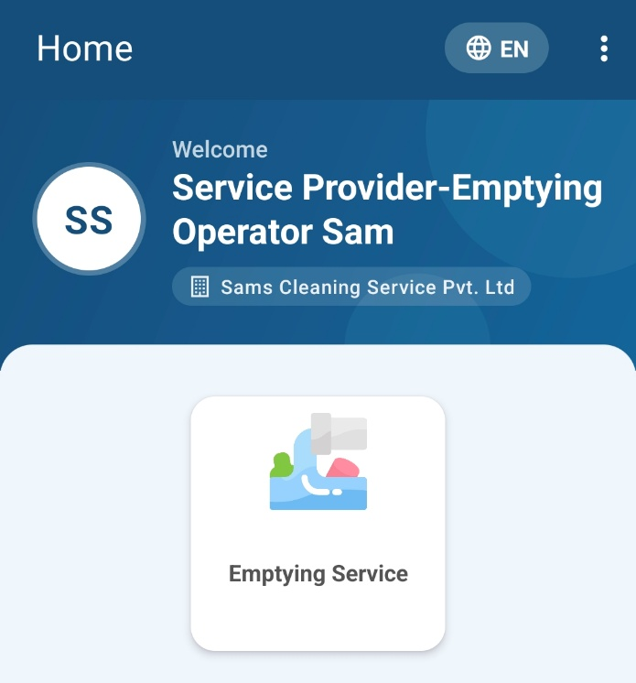
                - Emptying Service
Overview:
- To initiate the emptying service process, the user must first access the Emptying Service List page.
- After the user is directed to the emptying service list page, the user can see a list of applications to fill in the details related to the actual emptying operation.
- The user can fill in an application that is “Application Not Found” (ANF), which doesn’t have the building or containment survey data linked in the system or is a new building and containment.
- Tools
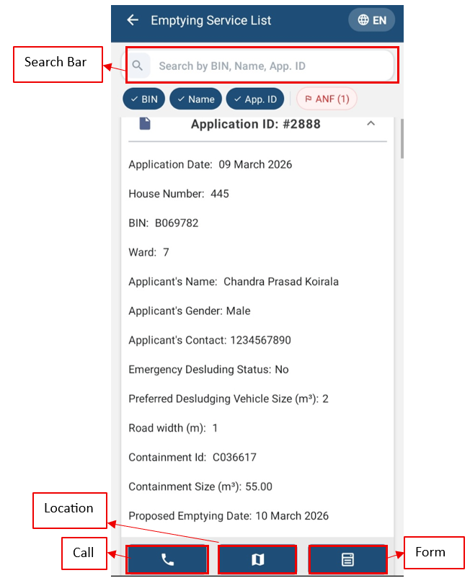
                - Emptying Service List

- Search Bar: To search, first select one or all buttons: BIN, Name, and App. ID. Enter the BIN, Name, or App.ID.
- BIN: Select the button to enter the BIN in the search bar.
- Name: Select the button to enter the name of the applicant in the search bar.
- App.ID: Select the button to enter the Application ID in the search bar.
- Call: Tap on the phone icon to call the Applicant directly.
- Location: Tapping on the location icon allows the user to view the location of the user’s containment that needs to be emptied on a map. After tapping the map icon, the user will be redirected to the Google Maps interface.
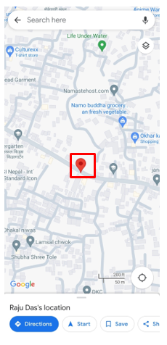
                - Location on Map
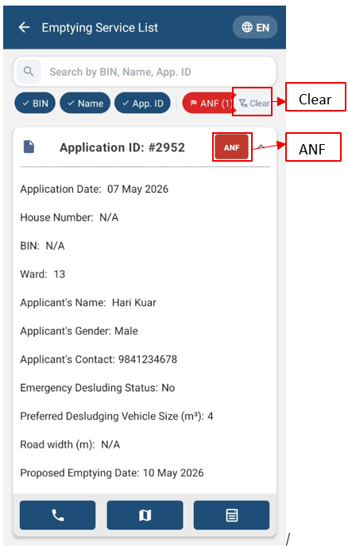
                - Emptying Service List ANF
- ANF: Click the ANF button; it will filter only the ANF application.
- Clear: The clear button removes the searched one and the active buttons.
- Form: Tapping on the form icon permits the user to fill out the form required for emptying the containment service.
Overview:
- Applicant locations are based on each application received.
- Emptying Service Data Collection
- Tapping on ‘Form’ redirects to the emptying service form.
- Fill out the form on-site with the required details, and the user must press the ‘SUBMIT’ button to upload the details to IMIS.
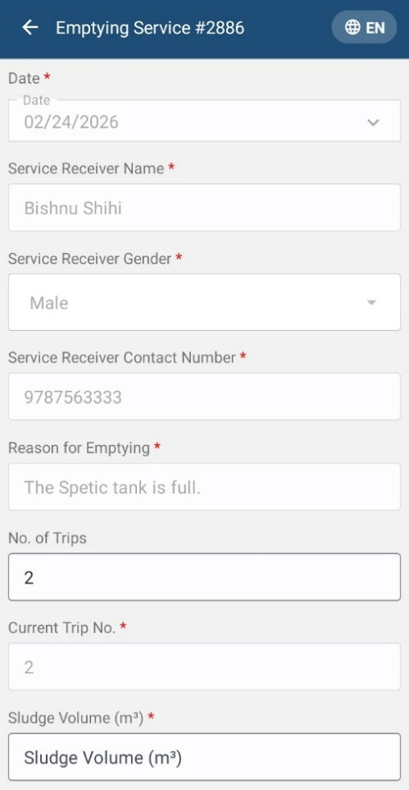 | 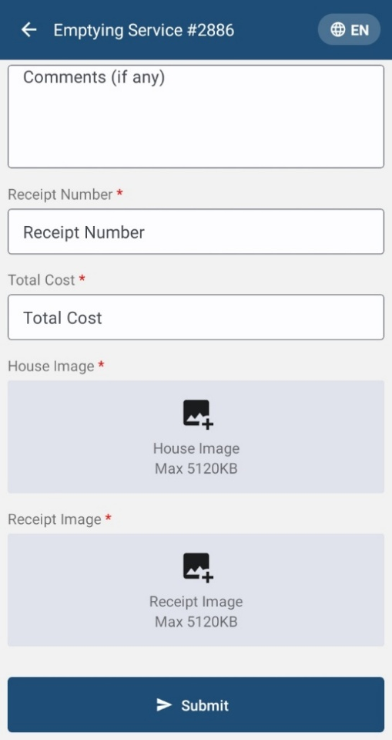

                - Emptying service form
Overview:
The Emptying service details page consists of different form fields, which are mentioned below:
- Date (A.D): The date is auto-filled.
- Service Receiver Name: Full name of the service receiver who was present at the time of emptying.
- Service Receiver Gender: The gender of the service receiver who was present at the time of emptying.
- Service Receiver Contact Number: Contact number of the service receiver who was present at the time of emptying (This field allows only numeric values).
- Reason for Emptying: The reason for which the containment was emptied.
- No. of trips: The total number of trips required to empty the sludge (This field allows numeric values).
- Current Trip No: It shows the current status of the trip and the phase it is in.
- Sludge Volume: The amount of sludge that has been collected. A rough estimation can be entered in a meter cube (m³)
- Desludging Vehicle Number Plate: The desludging vehicle license number plate, which is used for emptying
- Driver Name: Select the driver’s name who is responsible for operating the desludging vehicle.
- Emptier 1 Name: The name of the first emptier involved in the emptying process.
- Emptier 2 Name: The name of the second emptier involved in the emptying process.
- Start Time: The starting time of emptying the containment.
- End Time: The ending time of emptying the containment. The end time must be after the start time.
- Disposal Place: The treatment plant where the sludge is disposed of.
- Receipt Number: The receipt number generated after the emptying process.
- Total Cost: The total cost of the emptying process (This field allows only numeric values).
- House Image: Before submitting the form, the user must attach an image of the building where the sludge was emptied. If the house image is already available on the website, the option to upload a new house image will not be accessible, and you are not required to upload it from the mobile app. However, if the house image is not present on the website, the user will need to upload it from the mobile app.
- Receipt Image: The image of the receipt generated after the emptying process.
- Comments (If any): Comments to share the user's thoughts after the emptying process.
Note:
- For uploading the image of the House and Receipt, the maximum image size that should be uploaded is “5120 KB”. The submitted data is then sent to the IMIS web application. Also, the image format should be JPEG.
- All fields marked with an asterisk (*) are mandatory and must be completed to submit the form. If any necessary fields are left empty, the application will not permit the user to continue. Incomplete fields will be highlighted in red to show which ones need to be filled in.
- For multi-trip emptying service, the number of trips corresponds to the current trip number. When this is the case, the system will expand to show the receipt number, total cost, house image, and receipt image. If the number of trips does not match the current trip number, these fields will be hidden.
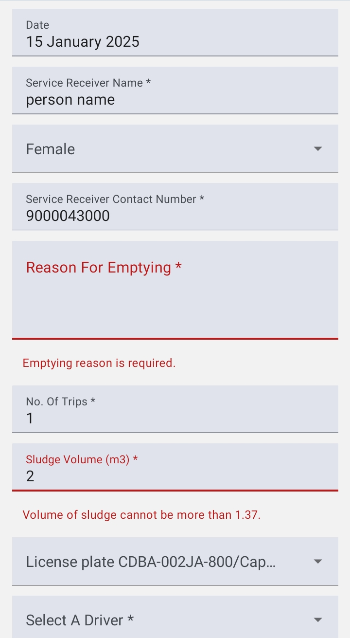
                - Empty Field Red Highlight

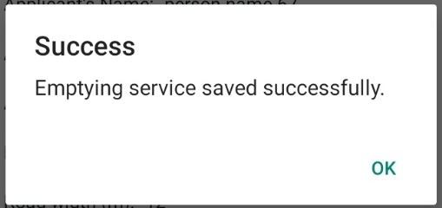
                - Success Message
If the application is ANF, the user must locate the building before completing the Emptying Service form, or it will not allow the user to fill out the Emptying Service application form.
- Tapping on ‘Form’ redirects to the emptying service form.
- Select the location icon.
- It will redirect to the Building Map.

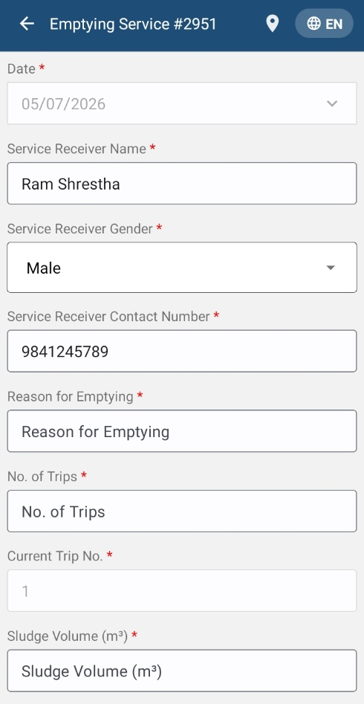
                - Emptying service form ANF
- Clear Map: Tap to remove the added marker.
- Switching Maps: Tap to toggle among various Google base maps, e.g., Street and Satellite.
- Locate Myself: Tap to locate the current position of the user.
- Zoom In/Out: Tap to zoom in and out of the map.
- Locate BNM: Tap the button, it redirects and locate to the Dhaka.
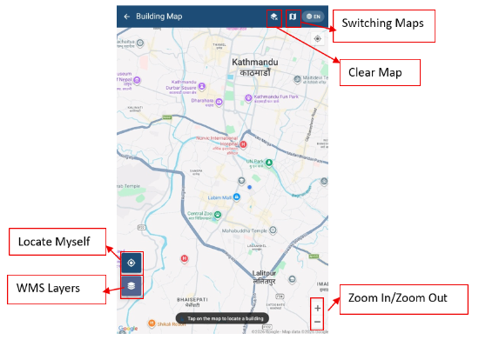
                - Building Map ANF
- WMS Layers: Tap to get WMS Layers of the map. The WMS Layers is a dynamic tool that draws an overlay on the Map. It can display the different layers of data, such as Building Data, Road Data, Ward Data, and Containment Data. This functionality allows the user to view digitized data stored in the database. When the user taps on the ‘WMS Layers’, a pop-up appears prompting them to select the desired layers. Once selected, the corresponding data layers are highlighted on the map.
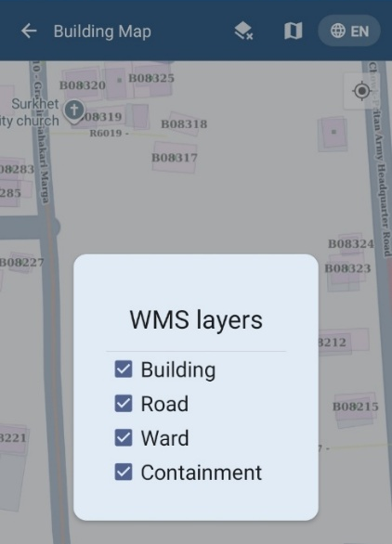
                - WMS Layers
- The ANF has three conditions when locating a building and filling out the form. In the following, the conditions are described:
- Building and Containment are known:
- The user locates the area where the building is, then taps on the building point.
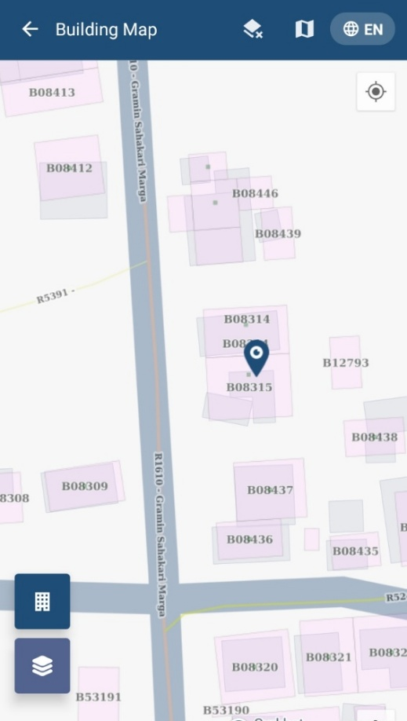
                - Tap the building location on the building map
- It pops up the Building Info that has both the Building and Containment Info.
- Click the “Select This Building” button.

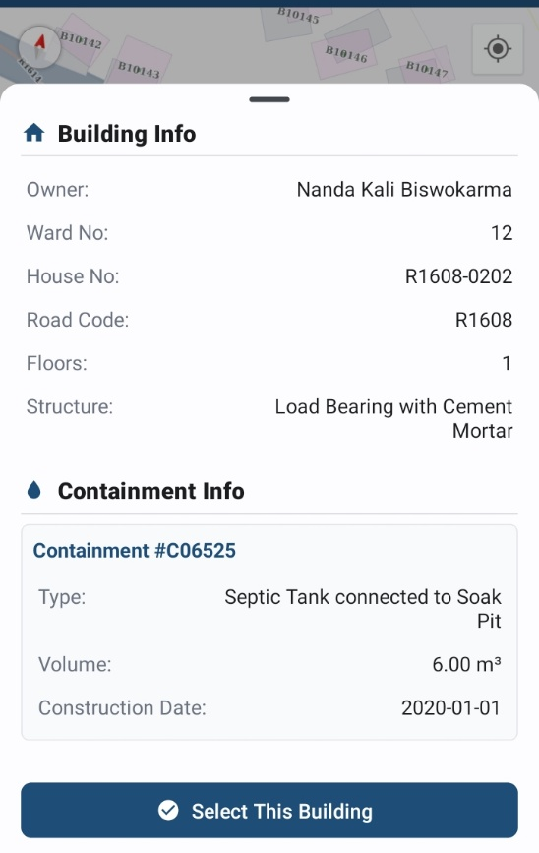
                - Building Info
- It will display the success message, click Ok and the Application ID will be linked with the selected building, and containment updates all the data.
- In the application card, update the BIN and Containment ID that were null.
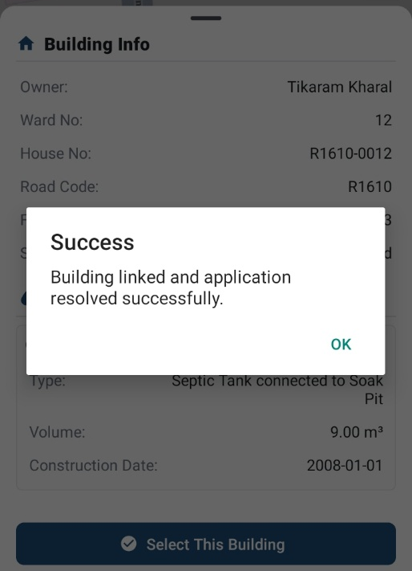
                - Building Linked to Application
- No Building Found:
- The user locates the area where the building is, then taps on the building point.
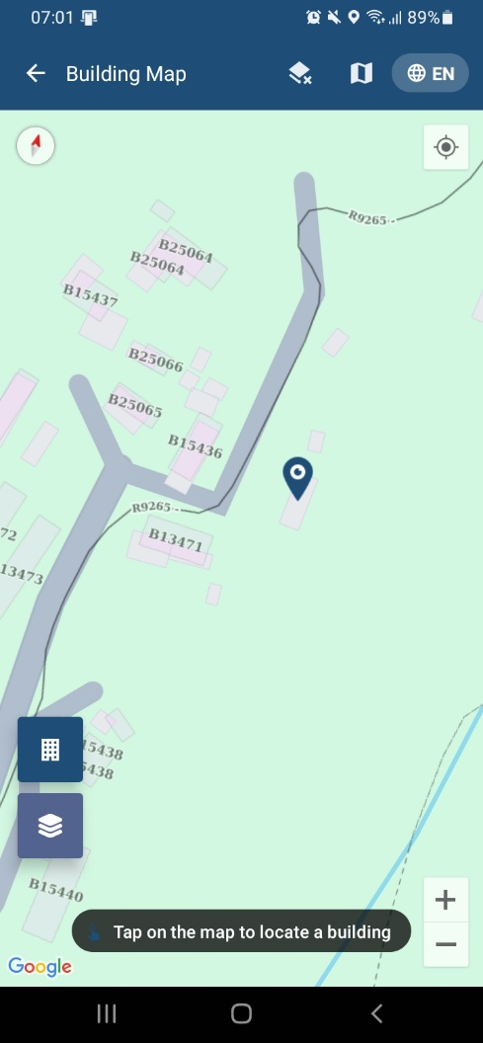
                - Tap the building location on the building map
- It pops up and displays No Building Found which indicates no record of the building at that selected location.
- It will also display the longitude and latitude of that location.
- To add the building, click the Add Building & Containment button.
- It pops up the add building & containment form.
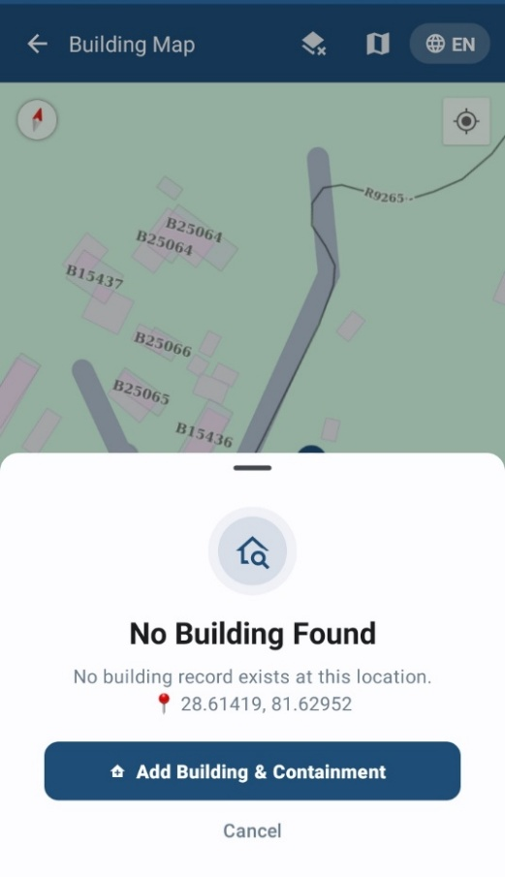
                - No Building Found
The Building & Containment form consists of different form fields, which are mentioned below:
- Application ID: It displays the selected Application ID that is prefilled.
- Owner Information:
- Owner Name: Enter the name of the owner of the building.
- Owner NID: Enter the National Identification Number (NID).
- Gender: Select the gender of the owner.
- Owner Contact Number: Enter the owner's contact number.
- Building Information:
- Ward: Select the ward where the building is situated.
- Road Code: Tap the drop-down, enter the road code in the search bar, and select the road code.
- House Number: Enter the house number.
- Construction Date: Select the construction date of the building.
- Structure Type: Select the building structure type.
- Number of Floors: Enter the number of floors the building has.
- Sanitation System Information:
- Presence of Toilet: The field is prefilled and displays “Yes”.
- Toilet Connection: Select either the Pit/Holding Tank or Septic Tank.
- Containment Information:
- Containment Type: The drop-down will display the containment type that is related to either the Pit/Holding Tank or Septic Tank toilet connection.
- Containment Size (m³): Enter the size of the containment building.
- Construction Date: Select the date when the containment construction was done.
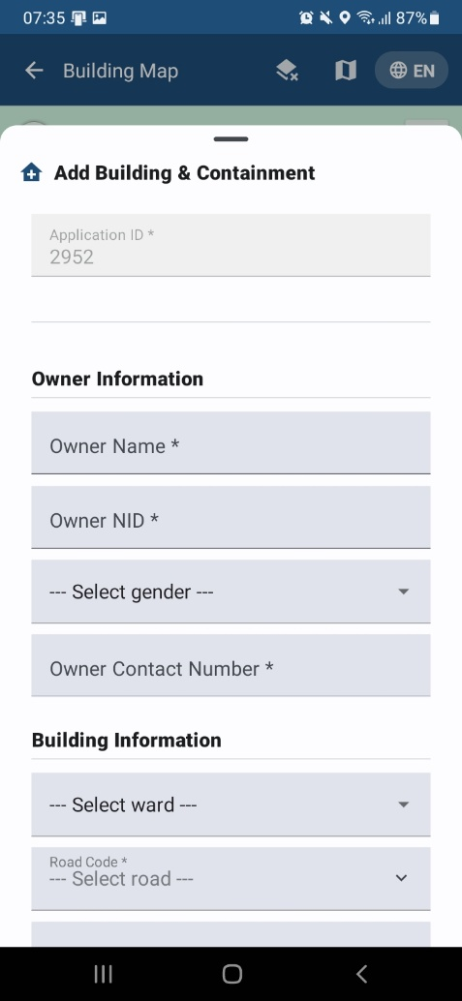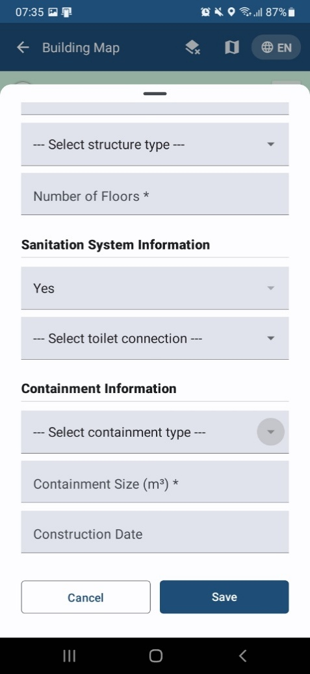
                - Add Building & Containment Form
- All fields are mandatory; the user is required to fill in all the fields and click the save button.
- It will display the success message, click Ok and the Application ID will be linked with the added building & containment and updates in the application. Also, created building & containment updates in the web system.
                - Building & Containment Linked to Application
3. Building Known but No Containment:
- The user locates the area where the building is, then taps on the building point.
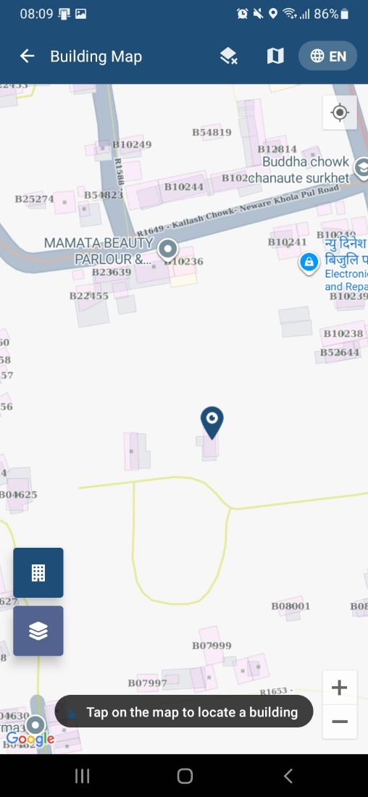
                - Tap the building location on the building map
- It pops up and displays Building Info, but no containment, which indicates no record of the containment.
- To add containment, click the “Add Containment” button.
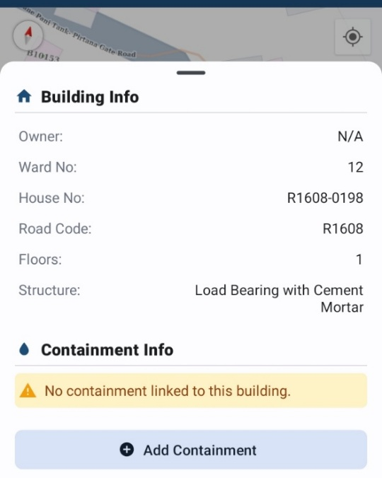
                - Add Containment
- It pops up the add containment form.
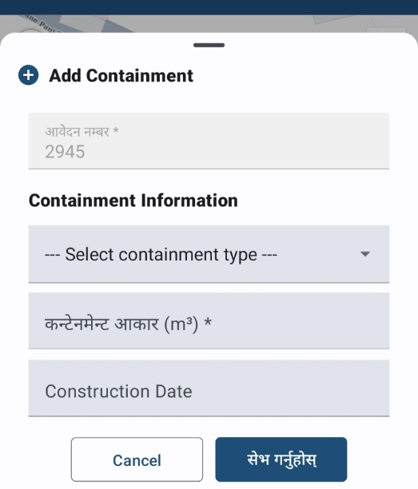
                - Add Containment Form
The Containment form consists of the following form fields:
- Application ID: It displays the selected Application ID that is prefilled.
- Containment Information:
- Containment Type: The drop-down will display the containment type that is related to either the Pit/Holding Tank or Septic Tank toilet connection.
- Containment Size (m³): Enter the size of the containment building.
- Construction Date: Select the date when the containment construction was done.
- It will display the success message, click Ok and the Application ID will be linked with the added containment and updates in the application. Also, created containment updates in the web system.
                - Building & Containment Linked to Application
Note:
- All fields are mandatory; the user is required to fill in all the fields and click the save button.
- The selected application that was ANF before will change to non-ANF, and the ANF will be removed from the application card, and also the location icon will be removed from the application emptying service form.

- MISCELLANEOUS (PERMISSIONS)
Overview:
- When the user first uses the application, they must provide the Location Permission to the app.
- Allow BNM IMIS to access this device's location requested by the app by clicking “WHILE USING THE APP”.
- The user is also prompted to turn on location services at all times while using the mobile application.
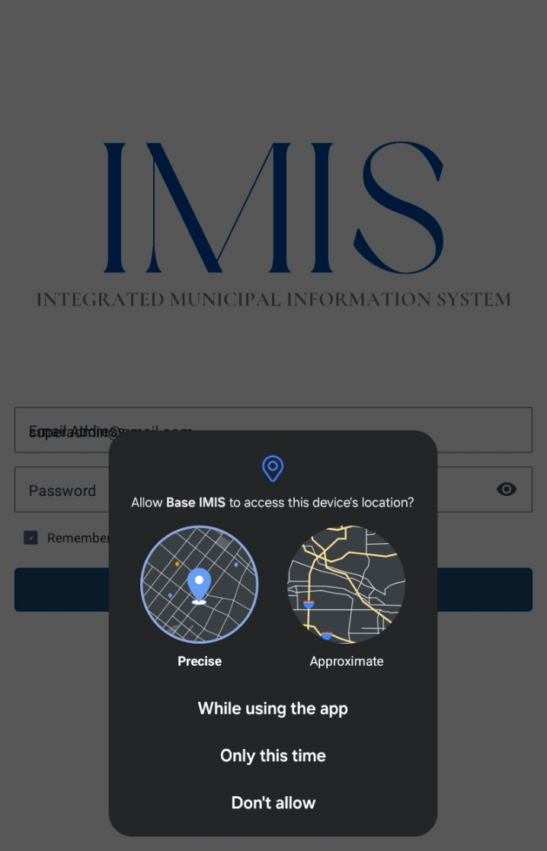
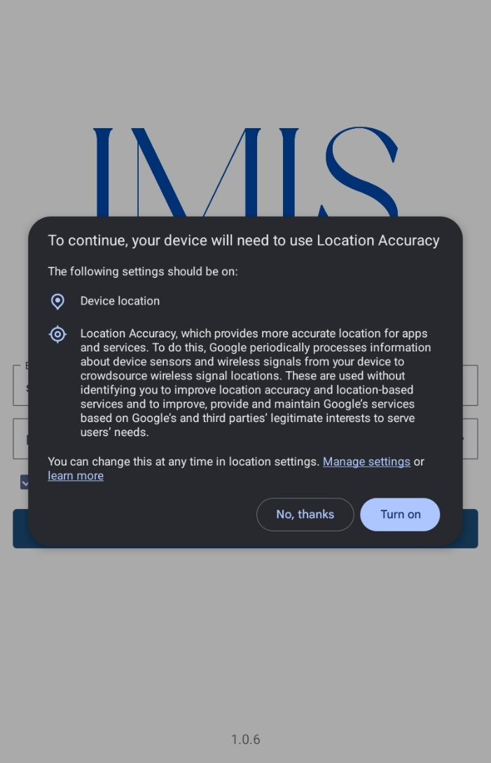

                - Location permission

